Jordan Mitchell

1/22/2025

Professor Chan

Module 3 Assignment: Android Studio Introduction

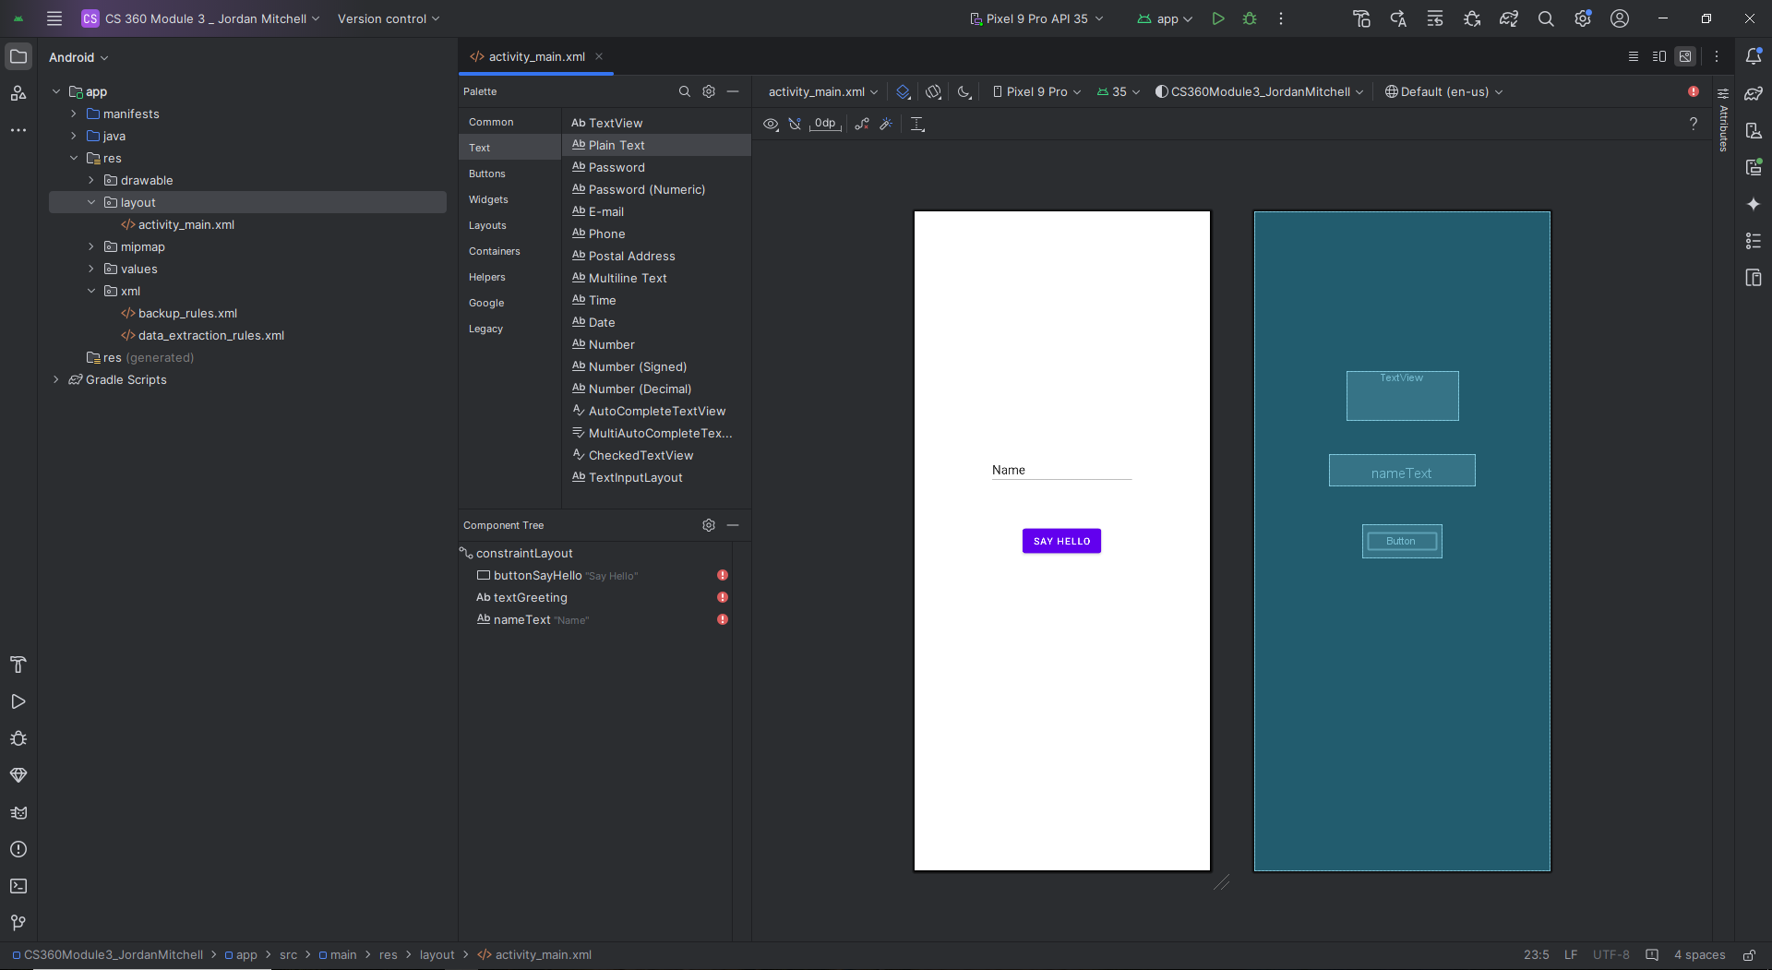  
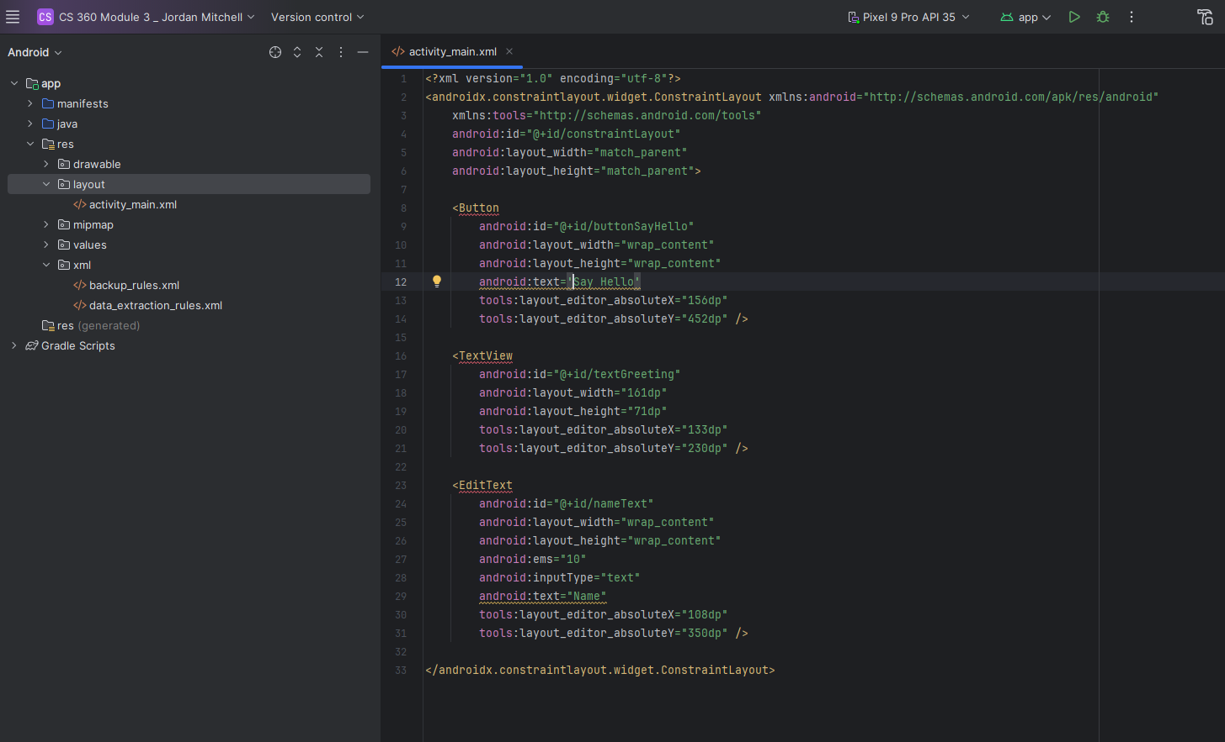   
   
 This was my first time using Android Studio, and I found the setup process to be the most challenging part. While installing the IDE was mostly straightforward with the provided instructions, I struggled when creating a new device in the Device Manager and determining whether additional SDKs were required. Once the environment was ready, working with the Layout Editor was much more intuitive. I appreciated features like the snap guides and alignment lines, which helped me center and organize elements like the button, TextView

I initially encountered some confusion about which layout to use, but I found that the constraint layout offered the flexibility I needed to position and adjust elements. The drag and drop function is simple and effective. The Attributes panel makes it easy to alter components. I found the Palette was well organized, and the visual Design Editor helped the process of placing and resizing components.

While I found this first assignment manageable, I recognize my need for more practice with Android Studio. For example, I initially created the XML file in the XML folder, which caused confusion until I restarted and placed it correctly in the app folder. Moving forward, I look to deepen my understanding of Android Studio's tools by finding additional tutorials and resources. Overall, I enjoyed the experience and am looking forward to building on these skills this term.